Provati Courier Ltd 2nd Phase Web Application

PCL 2nd – Project Plan

Prerequisites

- Existing Project 1st DB with relational diagrams & source code. Any kind of document describing workflow.

- Payment Api credentials. (If needed to integrate with Application)

- Others api credentials

- Need a Full time Laravel Developer & Android Developer from PCL Side.
- Tawk.to Chat Credential
- Server credentials (Live & staging Server).
- Server Migration to Digital Ocean to AWS Cloud after completing Project.
- Project Estimation Deadline without UAT: 7 Month
- Project Estimation Deadline UAT: 7.5 Month
- Resources for this Robust Project: 1. Software Architect (Apurba Narayan Singh)
2. Sr. Full Stack Developer (Sajib Khan Mrida)
3. Asst. Project Manager & DevOps (Debasish Das)
4. PCL Side 2 Developer (Laravel & Android)

Sprint wise Deliverables
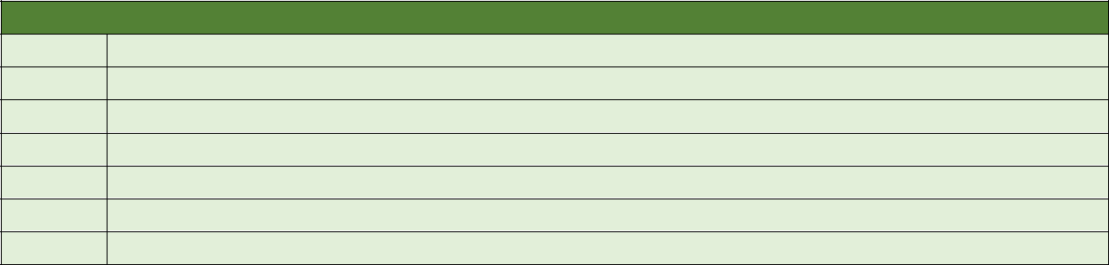

Sprint 1 (Week 01 – Week 06)

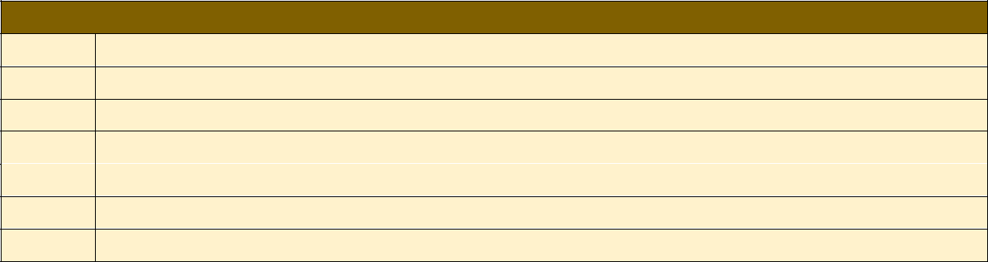

Sprint 2 (Week 07 - Week 12)

Sprint 3 (Week 13- Week 18)

Sprint 4 (Week 19 – Week 24 )

Sprint 5 (Week 25- Week 28)

